|  |  |  |
| --- | --- | --- |
| **CRM Implementation**  **Business case**   |  |  | | --- | --- | |  |  | |
|  |
|  |
|  |

**WARNING:** This document is uncontrolled unless viewed electronically from its original location. Where an uncontrolled document is used it is the responsibility of the person using it to ensure that it is the latest version.

Contents

ABOUT THIS DOCUMENT 2

VERSION CONTROL 2

EXECUTIVE SUMMARY 3

PROGRAMME RESOURCE 3

CURRENT BUSINESS CONCERNS 3

PROPOSAL 4

CRM SYSTEM BENEFITS 4

SOLUTION OPTIONS 5

# ABOUT THIS DOCUMENT

|  |  |  |
| --- | --- | --- |
| **Document purpose** | To provide justification for the proposed move from our current sales and marketing process to a new CRM. | |
| **Intended audience** | Pitman Sponsor (Lindsey Jones), Robson Moore Associates. | |
| **Scope** | Marketing & Sales | |
| **Related Documents** | <https://bit.ly/3fmkbqj>  <https://bit.ly/31reYFh>  [Salesforce](https://www.salesforce.com/uk/editions-pricing/sales-cloud/)  [ActiveCampaign](https://www.activecampaign.com/pricing?em=25000&term=yearly&features=1)  [MailChimp](https://mailchimp.com/pricing/marketing/?currency=GBP#plan:premium) |  |

# VERSION CONTROL

|  |  |  |
| --- | --- | --- |
| **Description of Change** | **Author** | **Version No.** |
| First Draft | Robson Moore | 0.1 |
|  |  |  |
|  |  |  |
|  |  |  |

|  |  |  |
| --- | --- | --- |
| **Document** | **Reviewer / Approver** | **Version No.** |
| Business Case | Lindsey Jones | 1.0 |
|  |  |  |

# EXECUTIVE Summary

Pitman Training Group (PTG) is a well-established organisation with over a hundred year history, specialising in the delivery of a wide range of courses, from accounting to design.

The company has grown its customer based rapidly with the onset on online teaching, it has since struggled to manage customer data effectively.

Previously the company managed all of their customer information manually using a combination of Microsoft office and excel. This has resulted in a number of issues concerning inefficiency, poor team collaboration and fewer insights.

The company has considered 3 main COTS (commercial off the shelf) products to host its customer data, these are, Salesforce, Active Campaign and MailChimp.

Based on a decision from the company sponsor – the business has chosen to adopt Active Campaign as its new CRM.

# Programme Resource

|  |  |
| --- | --- |
| **Name** | **Position** |
| Lindsey Jones | Programme Sponsor |
| Robson Moore | Project Lead |
| Robson Moore | Business Analyst |
| TBC | Developer |

# CURRENT BUSINESS CONCERNS

|  |  |  |
| --- | --- | --- |
| **Ref** | **Business Concern** | **Description** |
| **1** | **Stagnant customer experience** | Using a CRM helps you know more about your prospects, thus personalize messaging and provide more value from the start. So basically, not using a CRM will make it way tougher for you to do all of this and the customer experience that your business offers will be stagnant and underwhelming. |
| **2** | **Inefficiency** | Without a CRM, chances are you won't realize how much time your team spends on repetitive, tedious tasks, such as manually searching for customer information. Luckily, CRM is process-based, hence eliminates much of the inefficiency that affects your company and hurts its profitability. |
| **3** | **Poor team collaboration** | If you don't use CRM, it will be pretty difficult for members of the same and especially different teams to learn more about each other's best practices and pinch-hit for each other whenever someone goes on holiday or gets sick. |
| **4** | **Lack of follow-up** | When sales leads aren't followed up systematically, you can end up missing out on a lot of money-making opportunities. CRM provides the templates, workflows, processes, and reminders that increase follow-ups, which leads to more closed sales. |
| **5** | **Fewer Insights** | Without a CRM, it's not as easy to see how good your business is doing and how productive your teams are. A CRM system will give you both a high-level and on-the-ground picture of staff performance; this includes team-wide and individual conversion rates by deal stage, deal velocity, and average deal size. |

# PROPOSAL

The project sponsors will require the BA’s and PM’s to further explore the options and create a business case for the benefit of senior stakeholders.

**Budget**

£97k

This budget will consider Robson Moore’s expenses, any cost of development and the cost of running the platform for 3 years

**Contacts**

Pitman currently has an email list 27,321 – expected to grow to 35,000 by the end of the year.

**Users**

Pitman expects 2 marketing experts, 6 sales staff and 2 managers to use the CRM so 10 users in total.

# CRM SYSTEM BENEFITS

A fully integrated CRM can provide a wide variety of benefits, listed below are a few that Pitman can take advantage of:

|  |  |  |
| --- | --- | --- |
| **Ref** | **Feature** | **Benefit** |
| **1** | **Contact Management** | The ability to manage contacts anywhere in the business at any time from any smart device would be a massive boost to reducing admin and turnover times. |
| **2** | **Track interactions** | Tracking interactions and seeing how many people are interacting with your messages is a great way to track performance and set goals for the future. |
| **3** | **Schedule Reminders** | Never miss a follow up with a customer by setting in scheduled reminders via one platform. |
| **4** | **Email Marketing** | The ability to mass market to your customer base for free on autopilot could massively improve sales for the company. Drip campaigns can be created based on customer behaviour to entice them into the product/service they want, rather than sending them generic marketing campaigns. |
| **5** | **Increase Sales Performance** | CRM’s track every touchpoint a customer has with the business, all in one place, showing full context of customer interactions. Knowing the customer’s sales journey helps to close more sales. Automation and tools within the CRM help staff focus on the deal. |

# solution options

There are three main options for Pitman’s CRM:

**Option One - Salesforce**

*Salesforce is the biggest player in CRM, and is still considered one of the finest choices for small businesses.*

*But even for those who are just finding their feet with CRM, there is also great customer support, an intuitive interface and tutorials to help you make the most of their impressive tools.*

*And because Salesforce caters for businesses of all sizes, you can be sure it will scale as you do.*

**Salesforce Features**

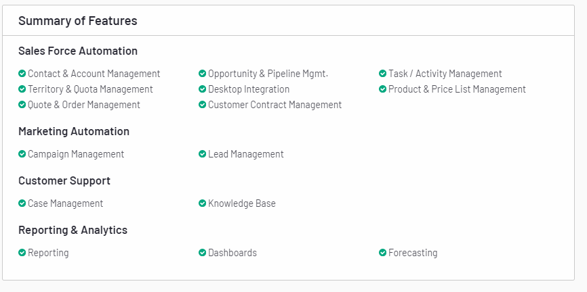

**Salesforce Cost**

Based on 10 Pitman users, the Professional package would cost £600, Enterprise £1,200 and Unlimited £2,400 per month:**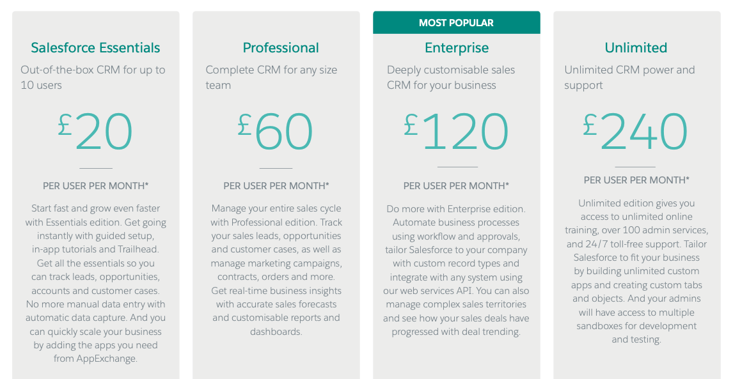Option Two – ActiveCampaign**

*ActiveCampaign's category-defining customer experience automation platform (CXA) helps over 130,000 businesses in 170 countries meaningfully engage with their customers.*

*The platform gives businesses of all sizes access to 500+ pre-built automations that combine email marketing, marketing automation and CRM for powerful segmentation and personalization across social, email, messaging, chat and text.*

*Over 75% of ActiveCampaign's customers use its 850+ integrations including Microsoft, Shopify, Square, Facebook, and Salesforce.*

**ActiveCampaign Features**

Features differ based on the type of package chosen. 10 Pitman users would use the CRM which means only the Enterprise package is suitable.

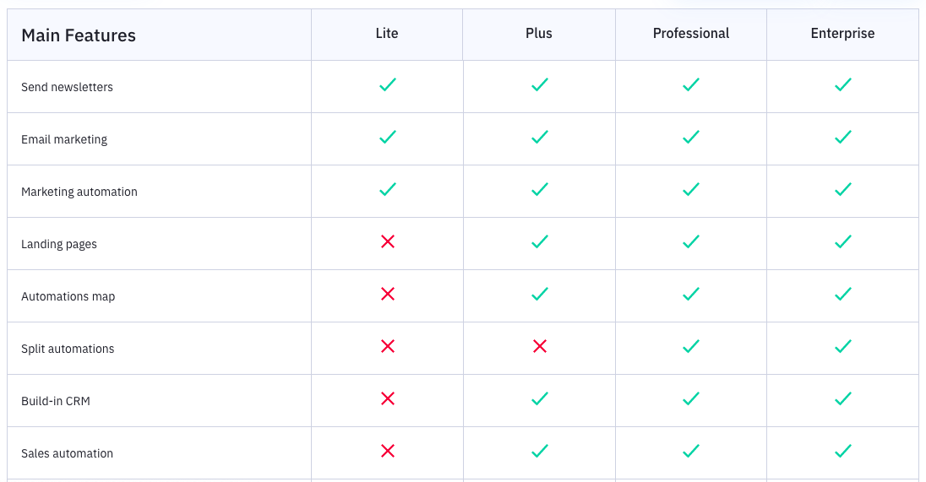

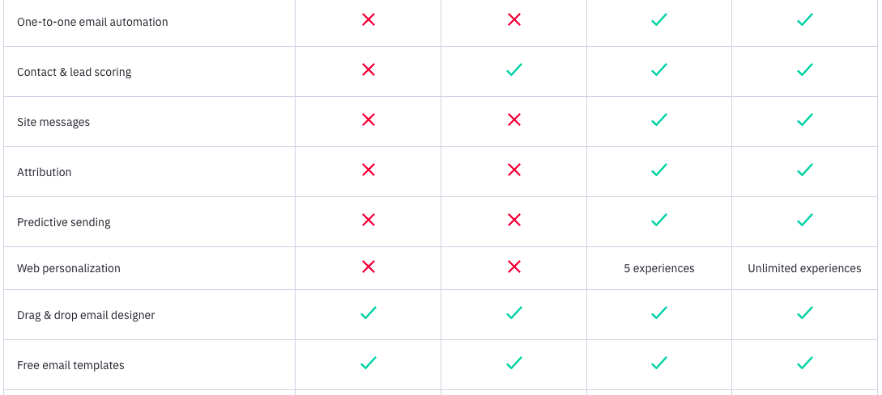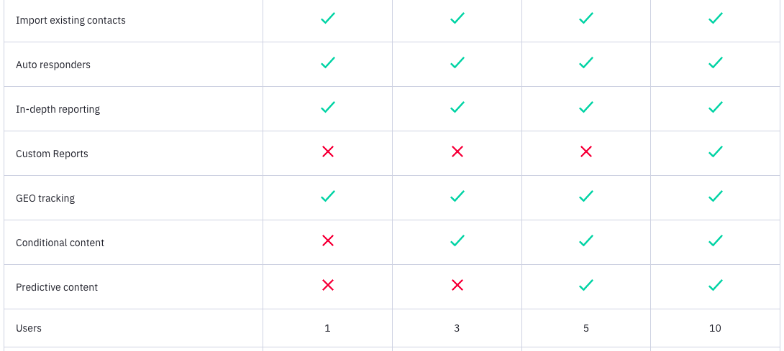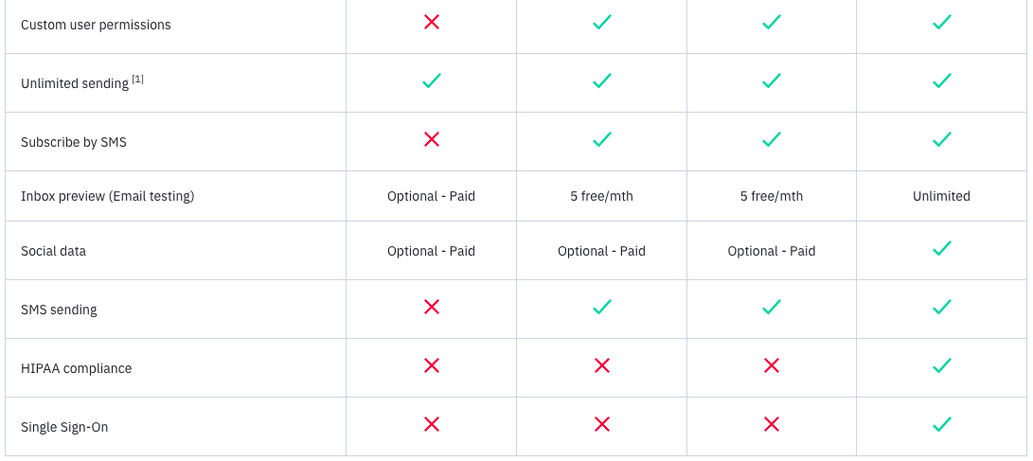

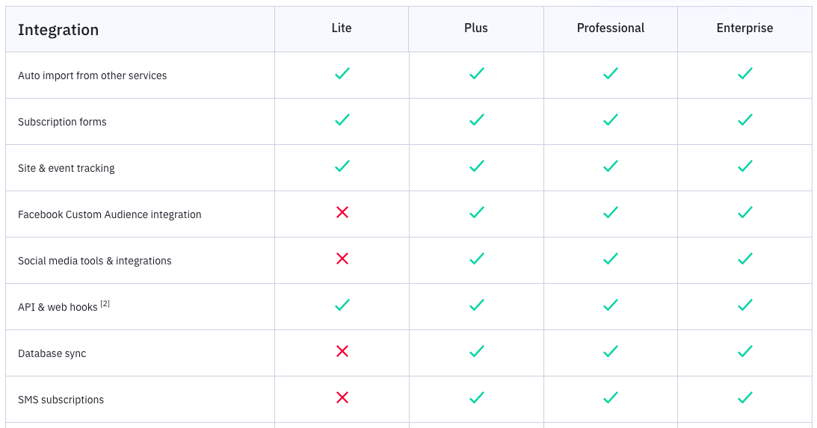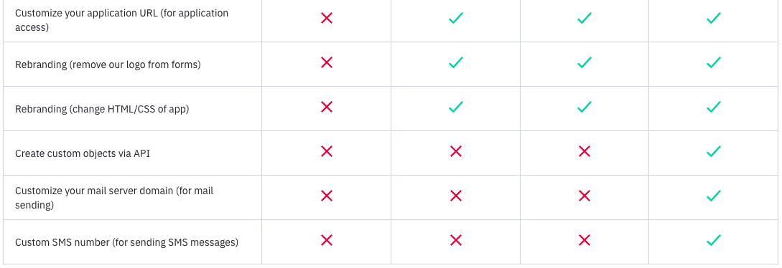

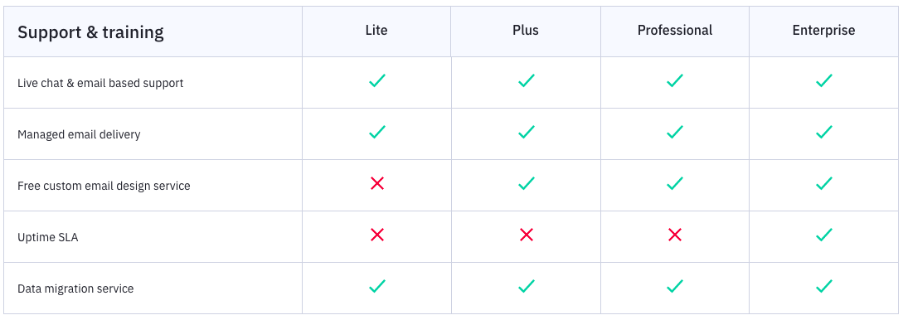

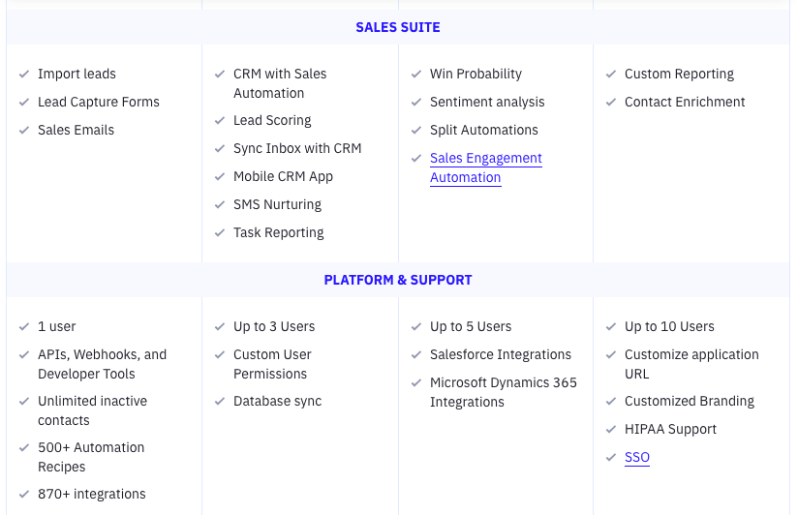

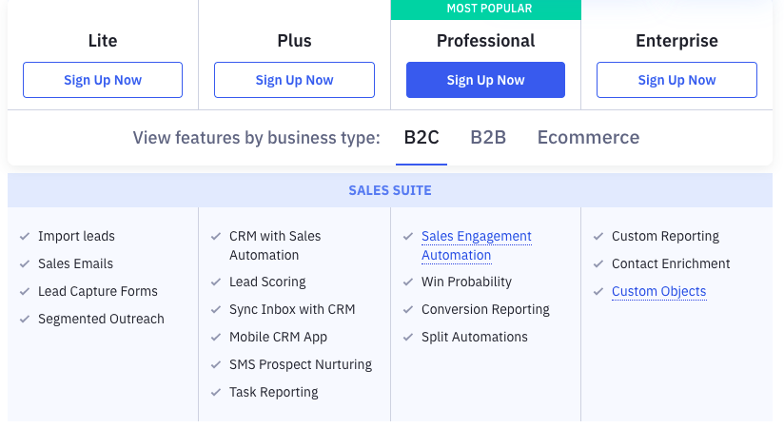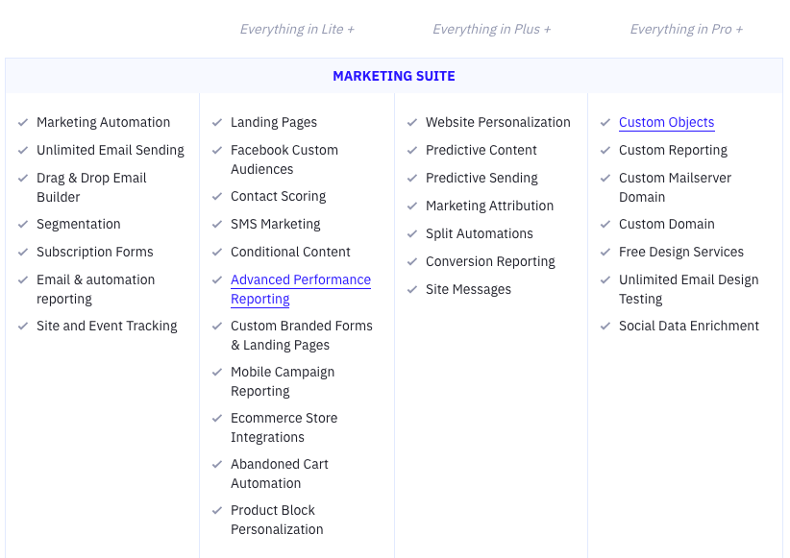

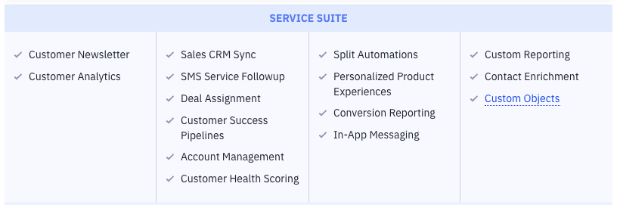

**ActiveCampaign Costs**

ActiveCampaign is significantly cheaper than Salesforce and provides very similar capabilities. Prices range based on the number of users and contacts which are 10 and 35,000 respectively. In order to get an accurate price on the Enterprise package, a sales quote needs to be requested due to the number of contacts Pitman has.

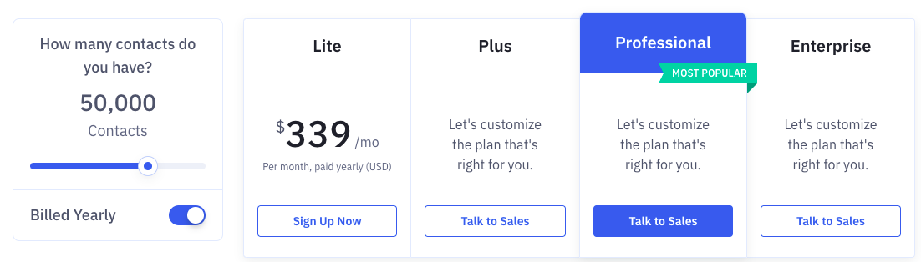

The starting price based on 500 contacts can be seen below:

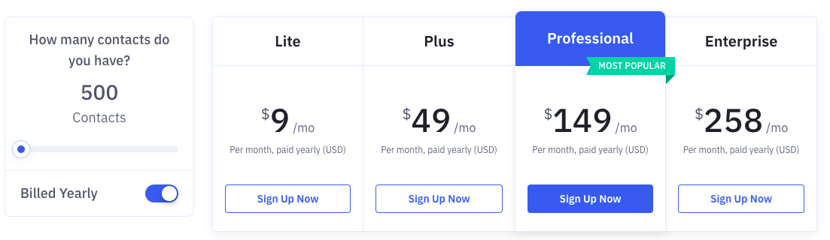

**Option 3 - MailChimp**

*Mailchimp’s all-in-one Marketing Platform helps small businesses market smarter so you can grow faster. As the backbone for your customer relationships, they provide AI-powered, user-friendly tools anyone can use to be successful. Mailchimp puts your audience at the centre so you can send marketing emails and automated messages, create targeted ad campaigns, build landing pages, send postcards, facilitate reporting and analytics, and sell online.*

*Millions of businesses and individuals - from community organizations to Fortune 100 companies - trust Mailchimp to connect with their audience with the right message, at the right time, in the right place. Founded in 2001 and based in Atlanta, GA, Mailchimp has 1000+ employees and is privately held.*

**MailChimp Features**

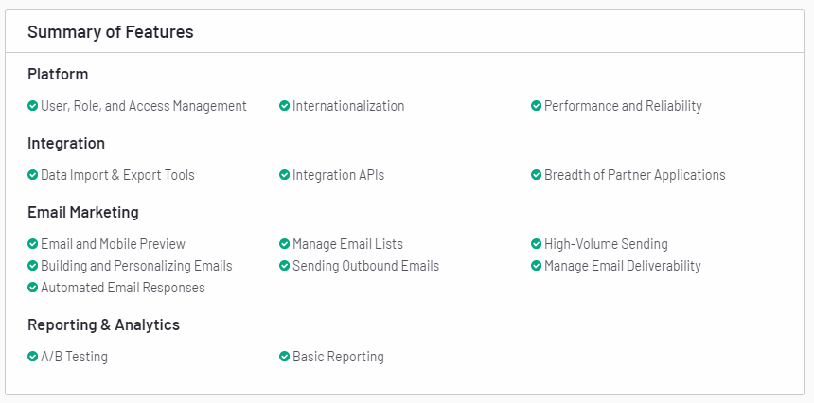

**MailChimp Costs**

In the image below, you can see costs based on typical number of users per package but Mailchimp can accommodate more than 10,000 contacts.

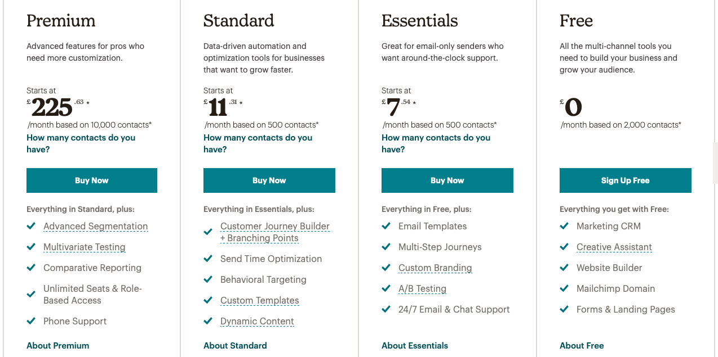

To service Pitman’s number of contacts, up to 40,000, the price will approximately start from £191.34 for Essentials, £213.42 for Standard and £426.83 for Premium per month.